Task 3: To create shapes like this.

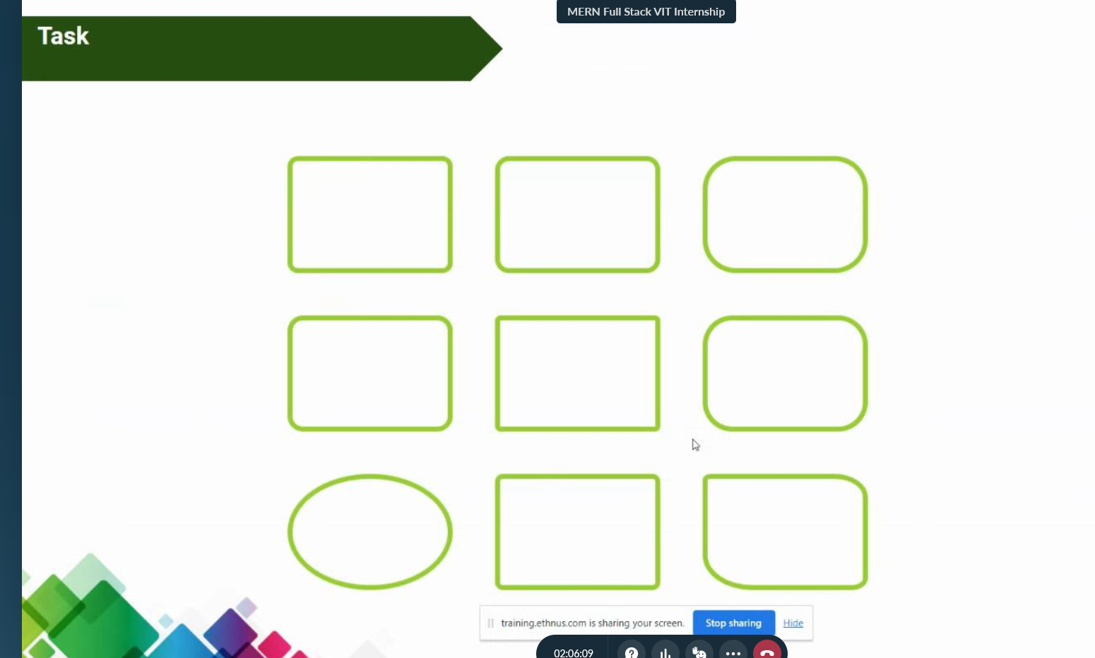

HTML code:

<html lang="en">

  <head>

    <link rel="stylesheet" href="shape.css" />

    <meta charset="UTF-8" />

    <meta http-equiv="X-UA-Compatible" content="IE=edge" />

    <meta name="viewport" content="width=device-width, initial-scale=1.0" />

    <title>Shapes task</title>

  </head>

  <body>

    <div class="grid-container">

      <div class="rounded-rectangle"></div>

      <div class="rounded-rectangle"></div>

      <div class="rounded2-rectangle"></div>

*<!-- </div> -->*

*<!-- <div class="grid"> -->*

      <div class="rounded-rectangle"></div>

      <div class="rectangle"></div>

      <div class="rounded-rectangle"></div>

*<!-- </div> -->*

*<!-- <div class="grid"> -->*

      <div class="oval"></div>

      <div class="rounded-rectangle"></div>

      <div class="rounded3-rectangle"></div>

    </div>

  </body>

</html>

CSS code:

\* {

  box-sizing: border-box;

  margin: 10px;

}

.grid-container {

  display: grid;

  grid-template-columns: repeat(3, 1fr);

  grid-gap: 10px;

}

.circle {

  width: 100px;

  height: 100px;

  border-radius: 50%;

  border: 3px solid greenyellow;

}

.oval {

  width: 120px;

  height: 80px;

  border-radius: 50%;

  border: 3px solid greenyellow;

}

.rounded-rectangle {

  width: 120px;

  height: 80px;

  border-radius: 8px;

  border: 3px solid greenyellow;

}

.rounded2-rectangle {

  width: 120px;

  height: 80px;

  border-radius: 50px;

  border: 3px solid greenyellow;

}

.rounded3-rectangle {

  width: 120px;

  height: 80px;

  border-top-left-radius: 8px;

  border-top-right-radius: 30px;

  border-bottom-left-radius: 30px;

  border-bottom-right-radius: 8px;

  border: 3px solid greenyellow;

}

.rectangle {

  width: 120px;

  height: 80px;

  border: 3px solid greenyellow;

}

Output:

